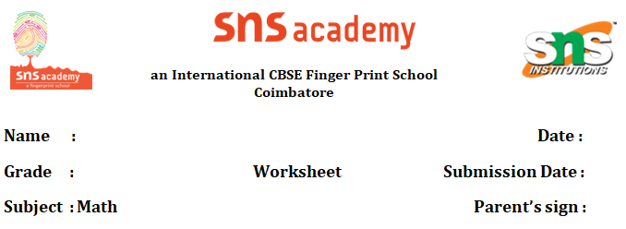

# Grade 7 Data Handling Question Bank

1. **Organizing Data**
   * Arrange in ascending order: 12, 5, 9, 15, 3, 10.
   * Group the data into a frequency table: 4, 7, 4, 9, 7, 4, 5, 9, 7.
   * Create a tally chart for: A, B, A, C, B, A, A, C, B.
2. **Mean**
   * Find the mean of: 6, 8, 10, 12, 4.
   * Calculate the mean of: 15, 20, 25, 10, 5, 30.
   * A student scored 85, 90, 78, 92, and 75. What is the mean score?
3. **Median**
   * Find the median of: 7, 3, 9, 12, 5.
   * Calculate the median of: 20, 15, 25, 10, 30, 5.
   * What is the median of: 4, 8, 6, 10, 2, 12, 8?
4. **Mode**
   * Find the mode of: 3, 5, 5, 7, 9, 3, 5.
   * Determine the mode of: 10, 15, 10, 20, 25, 15, 10.
   * Identify the mode of: A, B, C, A, A, B, C, C, A.
5. **Range**
   * Calculate the range of: 8, 12, 5, 15, 9.
   * Find the range of: 25, 40, 15, 30, 20.
   * What is the range of: 100, 85, 95, 110, 90?
6. **Bar Graphs**
   * Draw a bar graph for: Apples (5), Bananas (8), Oranges (3), Mangoes (6).
   * Interpret a bar graph showing sales: Jan (10), Feb (15), Mar (12), Apr (8).
   * Create a bar graph for student grades: A (4), B (7), C (5), D (2).
7. **Pie Charts**
   * Represent in a pie chart: Red (25%), Blue (35%), Green (20%), Yellow (20%).
   * Interpret a pie chart showing expenses: Food (40%), Rent (30%), Transport (20%), Others (10%).
   * Draw a pie chart for favorite sports: Soccer (50%), Basketball (30%), Cricket (20%).
8. **Line Graphs**
   * Plot a line graph for temperature: Mon (20°C), Tue (22°C), Wed (19°C), Thu (24°C).
   * Interpret a line graph showing sales over 5 days: 100, 120, 110, 130, 125.
   * Create a line graph for a student’s marks: Test 1 (80), Test 2 (85), Test 3 (90), Test 4 (88).
9. **Probability**
   * What is the probability of rolling a 4 on a 6-sided die?
   * A bag has 3 red, 2 blue, and 5 green balls. Find the probability of picking a blue ball.
   * Calculate the probability of getting heads when flipping a coin twice.
10. **Word Problems**
    * A survey recorded favorite fruits: Apple (10), Banana (15), Orange (5). Find the mean number of votes per fruit.
    * A student’s test scores are 90, 85, 95, 80, 100. Calculate the range and median.
    * A shop sold 20, 25, 30, 15, and 10 items over 5 days. Draw a bar graph and find the mode.
11. **Data Interpretation**
    * A table shows student heights (cm): 150, 155, 160, 150, 165. Find the mean and mode.
    * Interpret a pie chart of hobbies: Reading (30%), Gaming (40%), Sports (20%), Others (10%).
    * A line graph shows rainfall (mm): Jan (50), Feb (60), Mar (40). Predict the trend.
12. **Mixed Questions**
    * Find the mean, median, mode, and range of: 10, 15, 10, 20, 25, 15.
    * Draw a bar graph and find the probability of selecting a specific category from: Cats (4), Dogs (6), Birds (2).
    * Calculate the median and interpret a line graph for sales: 200, 220, 210, 230, 225.